The Great Gatsby
Recovery Assignment
Step #1: Watch the 2013 version of the movie The Great Gatsby. Complete the charts below as you watch the movie. Please make specific references to both the novel and the movie when taking notes below.
- CHARACTER ANLAYSIS:
 | NOVEL | FILM
NICK CARRAWAY
JAY GATSBY
TOM BUCHANAN
DAISY BUCHANAN
MYRTLE

- GATSBY PARTIES:
 | NOVEL | MOVIE
FIRST PARTY
SECOND PARTY
THIRD PARTY

- THE GREEN LIGHT: Compare & contrast the symbolic meaning of the green light using this table.
NOVEL | MOVIE

- T.J. ECKLEBURG BILLBOARD: Compare & contrast the symbolic meaning of the billboard that oversees the Valley of Ashes using this table.
NOVEL | MOVIE

- THE AMERICAN DREAM: Compare & contrast the symbolic meaning of the American dream.
NOVEL | MOVIE

- SETTING: Compare & contrast the setting of the novel vs. the setting of the film using this table.
NOVEL | MOVIE

Step #2: Using the information you have recorded, write a detailed compare/contrast analysis of the characters and setting in The Great Gatsby. This should be completed in 6-7 paragraphs with multiple (SPECIFIC) examples from BOTH texts (the novel and the movie).
**NOTE: You must use proper citations. Please click the link below to find out how to properly site a novel and a movie.
***NOTE #2: You MUST submit your essay via turnitin.com no later than February 17th by 11:59 p.m.
HOW TO CITE A MOVIE:
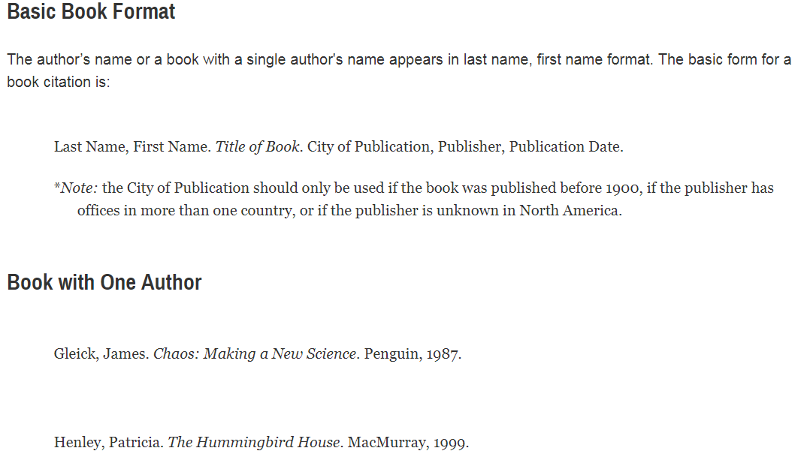
HOW TO CITE A NOVEL:

