The Masque of the Red Death
By Edgar Allan Poe

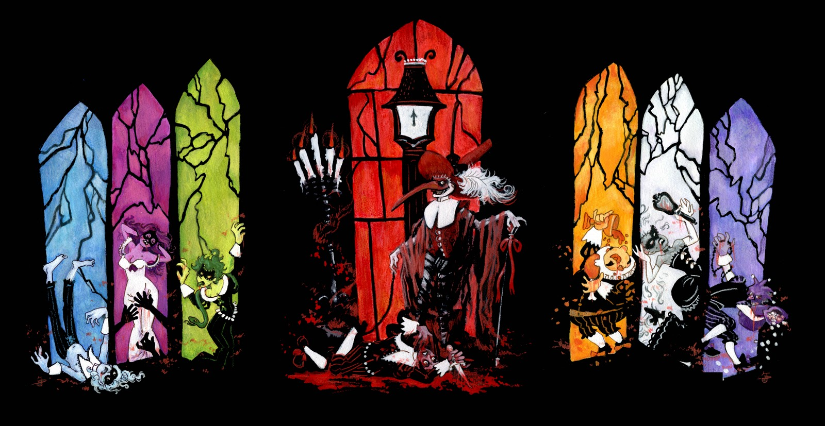

About the Author:
“Poe's work as an editor, a poet, and a critic had a profound impact on American and international literature. His stories mark him as one of the originators of both horror and detective fiction. Many anthologies credit him as the "architect" of the modern short story. He was also one of the first critics to focus primarily on the effect of style and structure in a literary work; as such, he has been seen as a forerunner to the "art for art's sake" movement. French Symbolists such as Mallarmé and Rimbaud claimed him as a literary precursor. Baudelaire spent nearly fourteen years translating Poe into French. Today, Poe is remembered as one of the first American writers to become a major figure in world literature.”

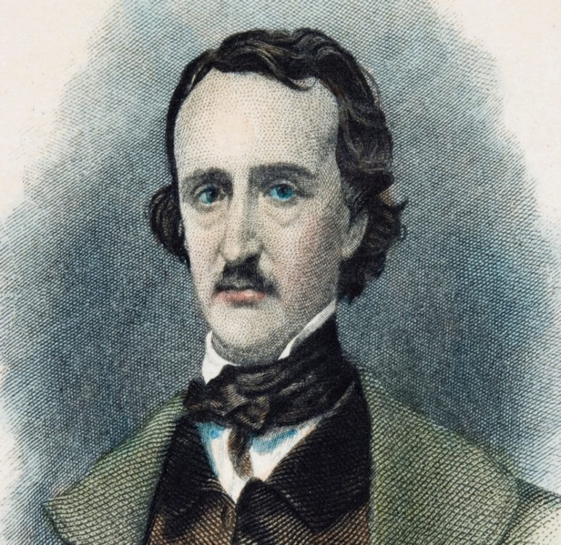

Read the story using this link: https://www.ibiblio.org/ebooks/Poe/Red_Death.pdf

Edgar Allan Poe

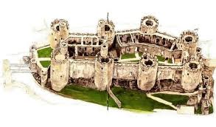
“Masque of the Red Death”—Symbolism and Floor Plan
The focus for this short story is on symbols and setting. These two elements work together to help
the reader understand the age-old fear of disease and death. To further analyze these elements, complete the activity below:

STEP 1: With your small group, read and ANNOTATE William Shakespeare’s “Seven Ages of Man” to more accurately fill out the chart below. This will help you to get a basic understanding of important elements from the story.
* Although we cannot say for sure what Poe intended for his colors, we can infer a deeper meaning based on Shakespeare’s “Seven Ages of Man.”

The Seven Ages of Man
from As You Like It, a play
by William Shakespeare
All the world's a stage,
And all the men and women merely players,
They have their exits and entrances,
And one man in his time plays many parts,
His acts being seven ages. At first the infant,
Mewling and puking in the nurse's arms.
Then, the whining schoolboy with his satchel
And shining morning face, creeping like snail
Unwillingly to school. And then the lover,
Sighing like furnace, with a woeful ballad
Made to his mistress' eyebrow. Then a soldier,
Full of strange oaths, and bearded like the pard,
Jealous in honour, sudden, and quick in quarrel,
Seeking the bubble reputation
Even in the cannon's mouth. And then the justice
In fair round belly, with good capon lin'd,
With eyes severe, and beard of formal cut,
Full of wise saws, and modern instances,
And so he plays his part. The sixth age shifts
Into the lean and slipper'd pantaloon,
With spectacles on nose, and pouch on side,
His youthful hose well sav'd, a world too wide,
For his shrunk shank, and his big manly voice,
Turning again towards childish treble, pipes
And whistles in his sound. Last scene of all,
That ends this strange eventful history,
Is second childishness and mere oblivion,
Sans teeth, sans eyes, sans taste, sans everything.

Symbol | Description:  1-3 quotes taken directly from the text & thoroughly explained | Possible Meaning:  Using “The Seven Ages of Man,” describe the deeper meaning of the symbols.
Prince Prospero
Courtiers
Building Alignment

Room 1
Room 2
Room 3
Room 4
Room 5
Room 6
Room 7
Corridor/Hallway
Tripods/Braziers/Torches
Clock
Stranger/Mummer

Allegorical Meaning of the Story:
Allegory is a figure of speech in which abstract ideas and principles are described in terms of characters, figures, and events. It can be employed in prose and poetry to tell a story, with a purpose of teaching or explaining an idea or a principle. The objective of its use is to teach some kind of a moral lesson.

____________________________________________________________________________________________________________________________________________________________________________________________________________________________________________________________________________________________________________________________________________________________________________________________________________________________________________________________________________________________________________________________________________________________________________________________________________________________________________________________________________________________________________________________________________________________________________________________________________________________________________________________________________________________________________________________________________________________________________________________________________________________________________________________________________________________________________________________________________________________________________________________________________________________________________________________________________________________________________

STEP 2: Now that you are an expert on the symbolism in the story, you draw a floor plan of the suite of rooms from the story. Your diagram must include the following:

- Title
- Author (show respect by spelling correctly!)
- Your Name
- 7 Rooms (arranged and colored precisely)
- Corridor/Hallway
- Torches/Braziers
- Ebony Clock Windows
- Doors
- Theme statement [complete sentence]
- Quotations [minimum of 3] (all MUST be significant to theme)
- Direction Key
- Map Key
  - You should include a description [1-2 sentences for each thing listed above] of WHY and HOW you placed everything on your floor plan.

Although there are many ways to make this floor plan wrong, there are also many ways to create it correctly. In a class with twenty students, I should expect twenty unique ways of drawing this floor plan, and all twenty could be correct if reading is done carefully! Use the text of the story to keep you on the right track. Especially helpful is the passage describing the castle which starts in the large paragraph on pages 4-5 and goes onto the description of the clock on pages 5-6. The last two pages of the story may serve as a good resource for quotations. The text won’t give you all the answers; you will need to interpret just where and how things should be drawn. Be extremely particular with color and its placement—it is very symbolic to the story!

RUBRIC

Title/Author spell correctly! 1 2
Quotations [3] theme 1 2 3 4 5
Seven Rooms color and order 1 2 3 4 5 6 7 8 9 10
Windows placement and color 1 2 3 4 5
Doors 1 2
Corridor/Hallway 1 2 3 4 5 6 7 8
Torches/Braziers 1 2
Ebony Clock placement 1 2 3
Direction Compass/Map Key 1 2 3

Total __________/40

