Literary Device Project
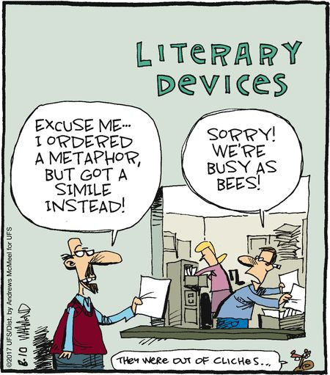
DIRECTIONS: Throughout the course of the week, you have learned many different literary devices through songs, raps, short stories, informative videos, and poems. Now it’s time to put your knowledge of each literary device to the test! Using a minimum of 20 of the terms listed below, create a storybook that demonstrates your knowledge of each term.

HOW WILL I BE GRADED? This project will count as a SUMMATIVE test grade. You will complete this project individually outside of class. No class time will be given to complete this project.

WHAT’S THE POINT? By continually working with literary devices, you gain a deeper understanding of the device and the impact of the device in any text. Growing more familiar with literary devices will help you tremendously when preparing for the IOC (individual oral commentary) in the spring. This project will also allow you to improve your annotating and close reading skills.

TERMS TO CHOSE FROM: anachronism, anaphora, anadiplosis, invective, euphemism, anecdote, juxtaposition, paradox, catharsis, didactic, litotes, zeugma, understatement, allegory, anthropomorphism, aphorism, foil, polysyndeton, pun, asyndeton, antihero, archetype, epiphany, allusion, caesura, colloquialism, connotation
GUIDELINES: Your storybook must meet the following requirements outside of the attached rubric-
- _______ 20 page minimum + 10 sentence minimum per page/device(that means 1 word per page)
(10 pts.)
- _______ Must be typed/written on white paper
- Each page must have a detailed & colorful picture that accurately depicts what is written. You may not use printed pictures.
(10 pts.)
- _______ ALL WORDS NEED TO BE YOUR OWN. You may not pull examples from any text/website/etc. The examples you use/story you create must be your own. (10 pts.)
- _______ Each page must display your knowledge of both the definition of the word AND how the word is used in literature. (***Note: Do not use the definition of the word in your storybook. You should display your knowledge of each term through more creative means.) (60 pts.)
- _______ Must be presented as a storybook, which means you must have a front cover, table of contents, and back cover-
- front cover should display a creative title for your storybook
- table of contents should list the terms in order with a detailed definition
- back cover should have a picture of you, the author, and a brief “about the author” blurb
(NOTE: front cover, table of contents, & back cover do not count in your 20 page minimum…)
(10 pts.)
- _______ MUST BE SUBMITTED ON TIME. As you know, I do not accept late work. This means that you may not take class time to print, put together, or color your storybook. Storybooks will be collected at the start of class on: A DAY= NOVEMBER 1ST; B DAY= NOVEMBER 2ND.

