Letter to Future Self
Setting goal is an important part of being successful. In this assignment you are going to be setting some goals for yourself in a letter that you will read again (and respond to) at the end of this semester.
STEP 1: Brainstorming: Set 2 different goals. 1. A goal for this class.
2. An overall goal for this school year.
Follow the outline to organize your ideas before you write your letter. Copy all words in bold, red font exactly. Substitute the remaining with your own ideas. This is an outline, so you may abbreviate and you do not need to use complete sentences.
Dear Future [insert your name here],
- INTRODUCTION [6 sentence minimum]
  - Introduce and tell about yourself
  - Quote someone you respect (someone famous) with a useful bit of advice they have given
  - Purpose (writing to set a goal)
  - How you think this grade will be (hard/easy), predication about the classes, teachers, etc.
  - State your goals
- GOAL #1: Goal for this class [6 sentence minimum]
  - Explain why you set the goal
  - Explain how you will achieve this goal
  - Other things you should discuss: importance, motivations, past experiences, advice you think might be especially useful for this goal
- GOAL #2: Goal for this school year overall [6 sentence minimum]
  - Explain why you set this goal
  - Explain how you plan to achieve this goal
  - Other things you should discuss: importance, motivations, past experiences, advice you think might be especially useful for this goal
- CONCLUSION: [6 sentence minimum]
  - Talk to your future self about when you open this letter in December. What do you like right now, how do you think/hope that will have changed?
  - Set one more personal goal that is not related to academics (but is still school appropriate).
  - Give your future self a piece of advice from your current self.
  - Closing sentence
Yours truly,
Sign your name

STEP 2: Once you have finished and completed your outline, you will begin writing your letter.
- Open a blank word document.
- Make sure your document is set to MLA formatting
  - font is 12 pt. Times New Roman
  - margins are all 1 inch
- Write your letter following the letter format:
This is where you would put an address. For this assignment, just put the school address.

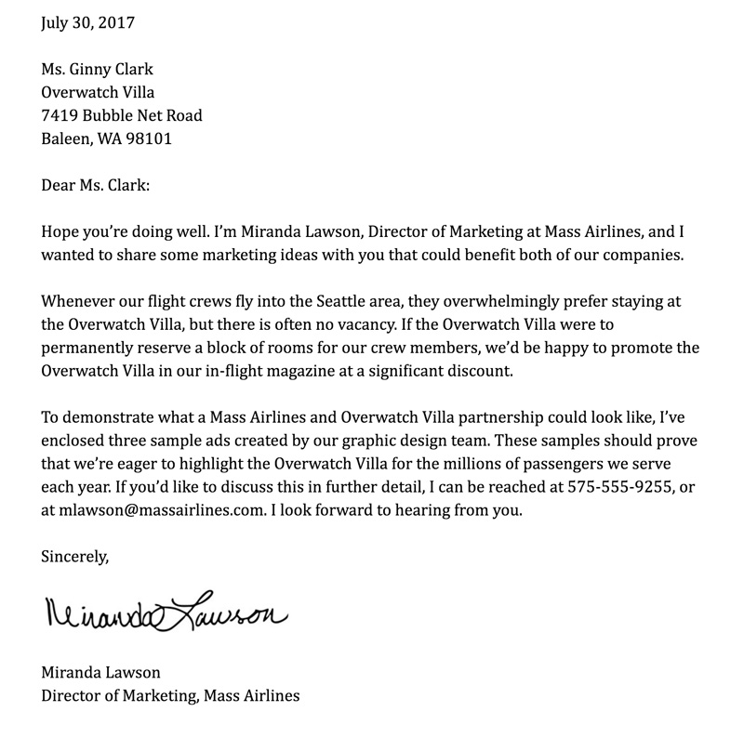
Finally, sign your name.
Put today’s date!
This is where you will use the outline you just created to write a letter to yourself!

STEP 3: REVISIONS
Now that you have finished writing your letter, you will revise your writing using this document. It is important to re-read what you have written before you submit. Please use the checklist attached below to revise your writing. I would like to see your revisions on your original letter. You may put your corrections in parenthesis in bold font.
*Hint: Look over the rubric to ensure you are meeting all expectations.
STEP 4: Submit to Ms. Thorne using the portal on the website: http://thorneslit.weebly.com/unit-1-the-american-dream.html
To submit, scroll down to Week #1, Day 2. You should see “Submit your ‘Letter to My Future Self’ here!” Type in the required information and upload your word document.

