Emotive Words & Phrases
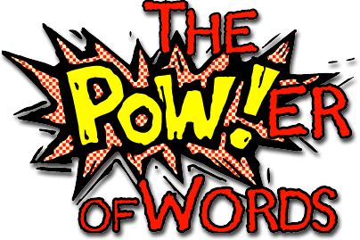
[INDIVIDUAL] Turn to page 6 and read from "So when Papa did not see Jaja..." to the end of page 7 "Even the glass dining table was moving toward me.” Lightly circle words (in pencil) that portray different emotions.
[WITH A PARTNER] Now, with a partner, discuss the choice of circled words and decide who was feeling the emotion, you as readers, or the characters in the text? What kind of link is there between reader and character?
[INDIVIDUAL] In 350 words, explore the link between the choice of emotive words and literary effect. Find 5 other examples of emotive words/phrases from our reading (pg. 1-36) and discuss the impact of each word. Are any of the words actually literary devices (onomatopoeia, alliteration, etc.)? If so, explain the device and how the author uses the device to add meaning to the text.
- (Emotive language pertains to word choice. Specific diction is used to evoke emotion in the reader. ... Different words can be used to cause different reactions in the audience. Any words that cause an emotional reaction are examples of emotive language.)
[WITH A PARTNER] Now, again with your partner, draw the scene in the room.

