Purple Hibiscus
Context of Composition
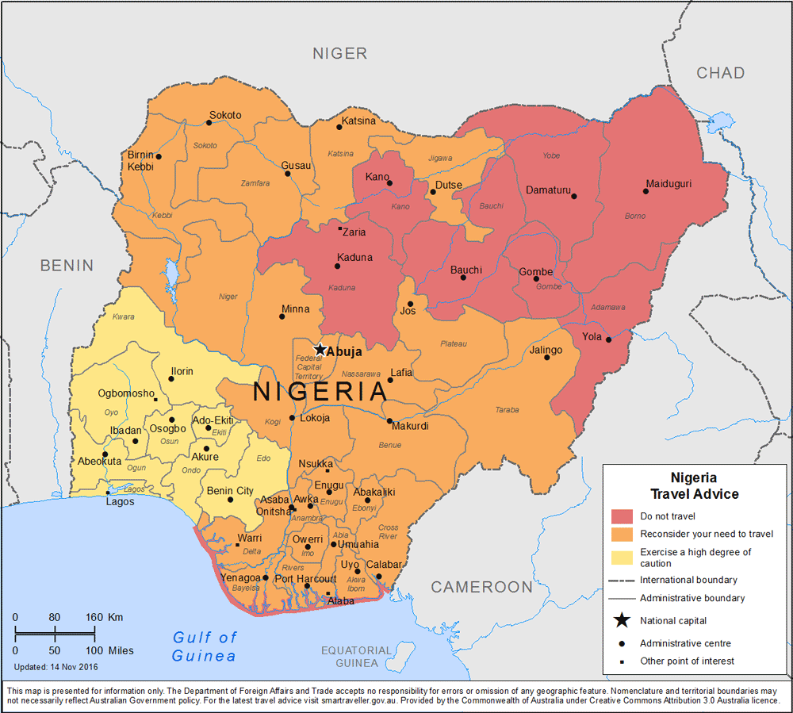
- Context of Composition Explained:
  - Writers can be influenced by the times in which they live, the place in which they write or the families from which they come. These factors contribute to what we call the 'context of composition.'
- Using the following links, research Nigeria as a country. Focus on Nigerian culture and Nigerian government and politics, particularly from the 1970s to present day. Make a Prezi depicting what you have discovered. Be prepared to present your Prezi to the class!
  - http://www.nigeria.gov.ng/index.php
  - https://en.wikipedia.org/wiki/Nigeria
  - https://www.bbc.com/news/world-africa-13949550
  - https://www.everyculture.com/
  - https://www.commisceo-global.com/resources/country-guides/nigeria-guide
  - https://www.everyculture.com/Ma-Ni/Nigeria.html

- Prezi requirements:
  - Explain the following in explicit detail-
    - Culture
    - Language
    - People
      - Men
      - Women & family
    - Traditions & rituals
    - Religion
    - Government
    - Major events that occurred from 1970-today (explain the impact of each event)
  - Research the novel:
    - Discuss the social, cultural, and historical context of the novel.
  - Explain how understanding the people, the place, and the culture will allow us to better understand the novel.
  - Quote and cite your sources.

