Name ____________________________
Focused Activity

Date ________Class _______

Score _____________________
Life of Pi

Characterization: Pi

Directions: Below is a chart to help organize the specific details of a character. Complete the chart using the details from Chapters 84-90.
(1) Appearance [quote directly from the text; direct AND indirect]
(2) Actions [quote directly from the text]
(3) Speech [quote directly from the text]
(5) Other’s Reactions [quote directly from the text]
(4) Thoughts [quote directly from the text]
Char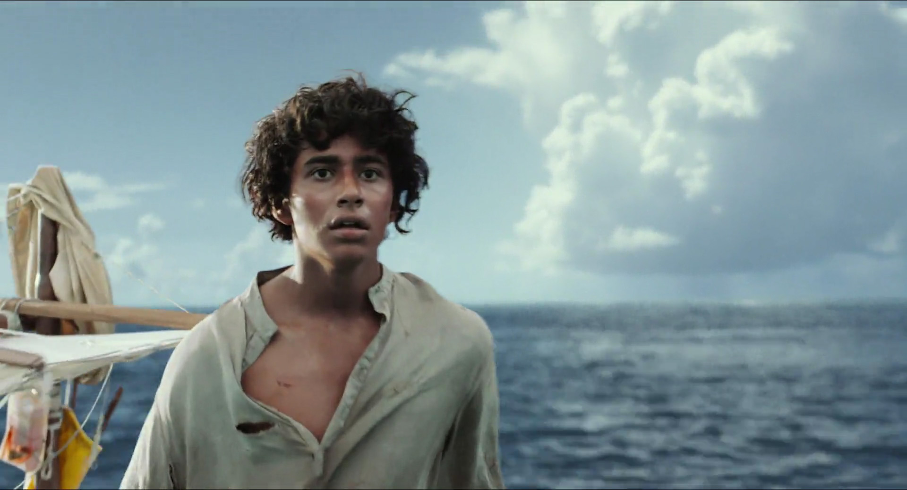acter

Directions: Below is a chart to help organize the specific details of a character. Complete the chart using the details from Chapters 84-90.
(1) Appearance [quote directly from the text; direct AND indirect]
(2) Actions [quote directly from the text]
(3) Speech [quote directly from the text]
(5) Other’s Reactions [quote directly from the text]
(4) Thoughts [quote directly from the text]
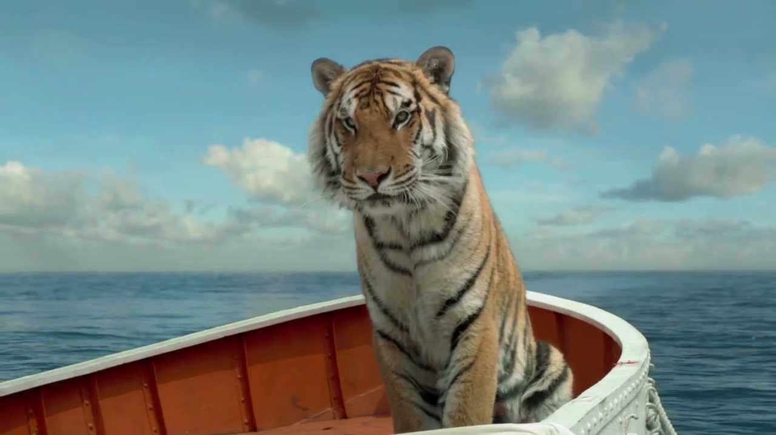

Based on the details you have listed, what is your impression of Pi [You are essentially JUSTIFYING what you wrote above using CEI.]:
____________________________________________________________________________________________________________________________________________________________________________________________________________________________________________________________________________________________________________________________________________________________________________________________________________________________________________________________________________________
________________________________________________________________________________________________________________________________________________________________________________________________________________________________________________________________________________________________________________________
________________________________________________________________________________________________________________________________________________________________________________________________________________________________________________________________________________________________________________________________________________________________________________________________________________________________________________________________________________________________________________________________________________________________________________________________________________________________________________________________________________________________________________________________________________________________________________________________________________________________________________________________________________________________________________________________________________________________________________________________________________________________________________________________________________________________________________________________________________________________________________________________________________________________________________________________________________________________________________________________________________________________________________________________________________________________________________________________________________________________________________________________________________________________________________________________________________________
Based on the details you have listed, what is your impression of Richard Parker [You are essentially JUSTIFYING what you wrote above using CEI.]:
__________________________________________________________________________________________________________________________________________________________________________________________________________________________________________________________________________________________________________________________________________________________________________________________________________________________
______________________________________________________________________________________________________________________________________________________________________________________________________________________________________________________
____________________________________________________________________________________________________________________________________________________________________________________________________________________________________________________________________________________________________________________________________________________________________________________________________________________________________________________________________________________________________________________________________________________________________________________________________________________________________________________________________________________________________________________________________________________________________________________________________________________________________________________________________________________________________________________________________________________________________________________________________________________________________________________________________________________________________________________________________________________________________________________________________________________________________________________________________________________________________________________________________________________________________________________________________________________________________________________________________________________________________________________________________________________________________________________________________________________________________________________________________________________________________________________________________________________________________________________________________________________________________________________________________________

