Symbolism Project:
I Am Nujood, Age 10 and Divorced
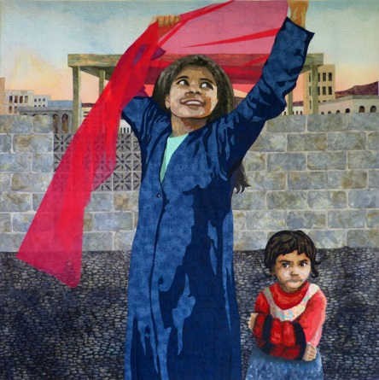

After reading Chapter 5, you should have a better understanding of each character in the text. This project will allow you to further explore the characters and their relationships through symbolism.

OBJECTIVE: to create a visual artifact that symbolically depicts one of the character/relationships below:
- Nujood
- Nujood & Mother-in-Law
- Him & Mother-in-Law
- Nujood’s Parents
REQUIRMENTS:
- visually appealing (printer paper, color, neat)
- S.T.E.A.L the character
- includes at least 7 piece of textual evidence
  - must include page #
- includes a theme from the novel
- must present your visual artifact to the class
- include written explanation (2 CEI paragraphs) explaining your visual artifact
  - theme
  - symbols
  - character(s)

PBA Rubric:

_________/50pts. Your visual artifact contains at least 7 pieces of textual evidence that fit your visual and describe the character(s) chosen.

_________/25pts. Your visual artifact’s concept is creative and contains a unique way to help us visualize these characters. It is colorful and well-thought out.

_________/10pts. Your visual artifact contains a theme of the novel.

_________/15pts. Your visual artifact comes with a written explanation of at least two paragraphs, using the CEI method of writing (Claim, Evidence, Interpretation).
- Every member of the group is responsible for writing his/her own written explanation.

Standards Met:
ELAGSE9-10RL6: Analyze a particular point of view or cultural experience reflected in a work of literature from outside the United States.

ELAGSE9-10RI2: Determine a central idea of a text and analyze its development over the course of the text, including how it emerges and is shaped and refined by specific details; provide an objective summary of the text.

ELAGSE9-10RI3: Analyze how the author unfolds an analysis or series of ideas or events, including the order in which the points are made, how they are introduced and developed, and the connections that are drawn between them.

