Name ____________________________

Date ________Class _______

Score _____________________
Life of Pi

Chapters 6-10
Activity Guide Questions

Directions: Read the chapters and answer the questions below in complete sentences.
COMPREHENSION
- In Chapter 6 what does the fictitious author notice about Pi’s kitchen cupboards?

- How does Pi describe an atheist?

- How does Pi describe an agnostic?

- In Chapter 7 Pi introduces the reader to his biology teacher Mr. Satish Kumar. Reread the first two paragraphs and complete the items below.

List the three phrases or sentences that BEST capture the physical traits of Mr. Kumar:

1.

2.

3.

List the three phrases or sentences that BEST capture the personality traits of Mr. Kumar:

1.

2.

3.

- Fill-in-the-Blank: At the beginning of Chapter 8 Pi comments that “the most dangerous animal in a zoo is ____________________________.”

- Fill-in-the-Blank: “I learned the lesson that an animal is an animal, essentially and practically removed from us, twice: once with ________________________ and once with ________________________.”

- After Pi’s father gives Pi and his brother Ravi the important “lesson,” what does Ravi say to Pi?

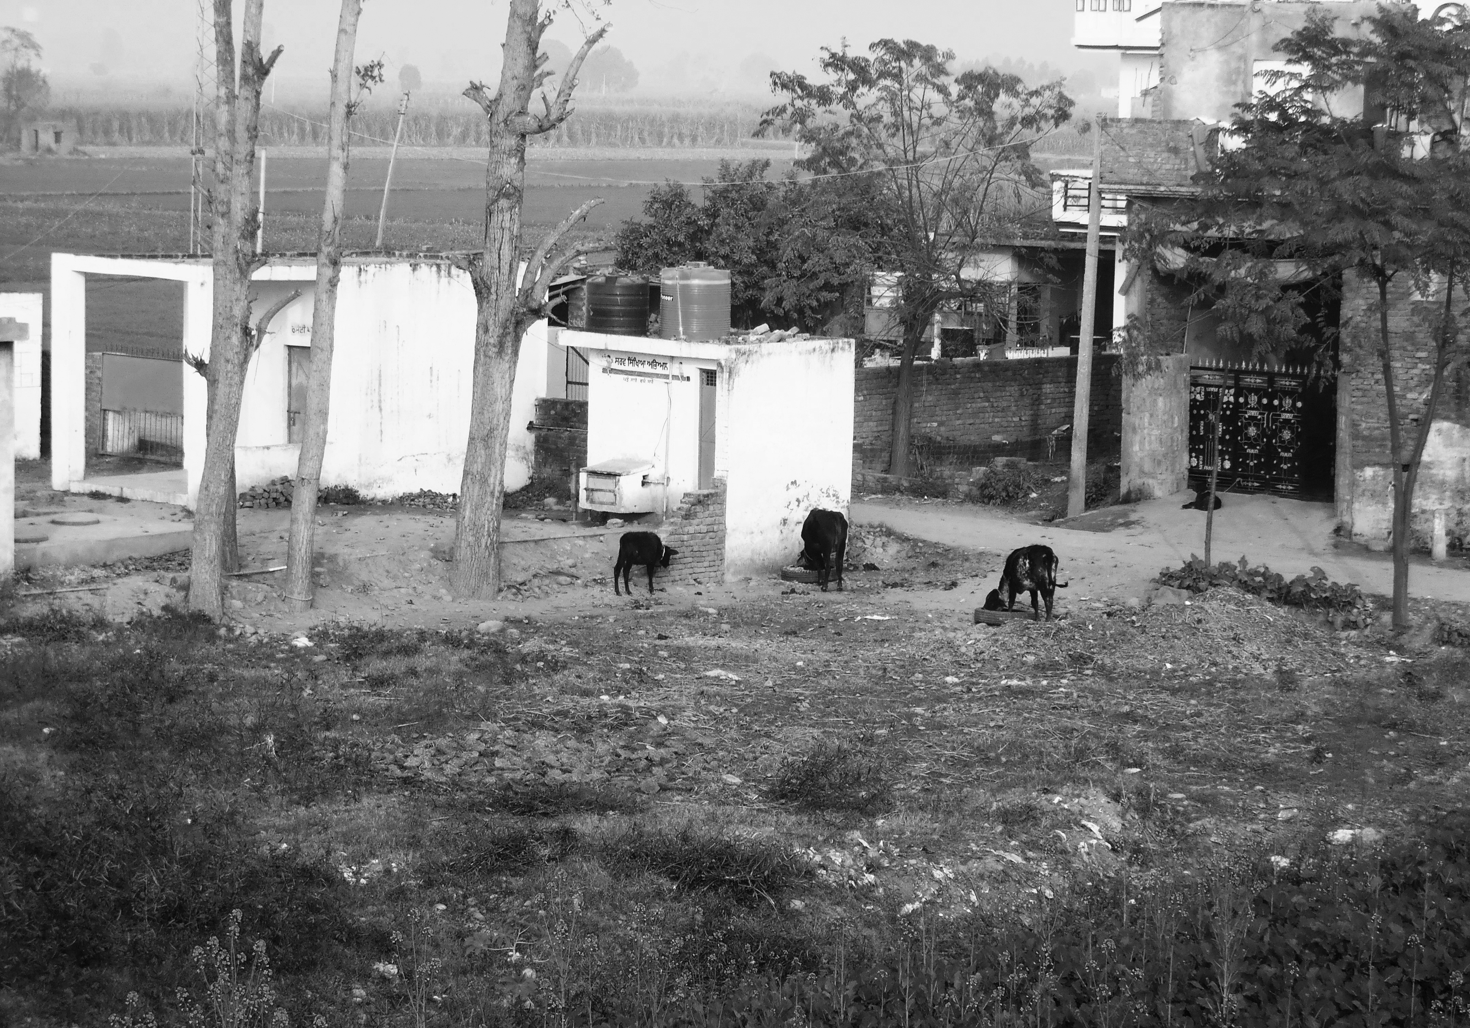
APPLICATION
- On page 26 in Chapter 7, Pi discusses the arrangement of two unlikely animals living together. What are the unlikely animals? Briefly describe their relationship:

- In chapter 8 Pi’s father teaches him that “an animal is an animal.” Describe the lesson with the tiger and the goat. What is the point of Pi’s father’s lesson?

- Beginning on page 36 Pi’s father gives Pi the lesson that animals are very dangerous. Complete the chart below by writing the danger of each animal.

Animal | Danger
hippo
hyena
orangutan
ostrich
spotted deer
black swan
elephant

- Describe the concept of an animal’s flight distance from Chapter 9:

ANALYSIS/SYNTHESIS
A motif is any recurring element in a story that has symbolic significance
Motif
- Find one passage (1-3 sentences) that reflects each motif below and write the passage word-for-word. Include the page number after your passage.
Faith/reason:

Projecting human qualities on animals:

Madness:

Personification is a type of figurative language. The use of personification is when an inanimate object is given the characteristics as being a living person or animal.
Personification and Diction (word choice)

- How is personification used in this passage on page 39: “When I went by the rhinoceros pit I fancied the rhinos’ head were hung low with sadness over the loss of one of their dear companions”?

What does Pi’s diction suggest about his personality? Reference specific words in your answer.

The word character derives from the Greek verb charassein, meaning to mark with a cut. Characterization is the method used by an author to develop a character. When an author introduces the reader to the characters within the work, he or she has two choices: to use direct and indirect characterization.

Character Development

- How does Mr. Kumar play an important part in Pi’s life?

UNIVERSAL THEME
- On page 41 Pi comments, “All living things contain a measure of madness that moves them in strange, sometimes inexplicable ways. This madness can be saving; it is part and parcel of the ability to adapt. Without it, no species would survive.” What does he mean by the word “madness”? And, how does this madness help species survive?

READER-RESPONSE/PERSONAL CONNECTION
Directions: Read the response question below and write one paragraph in the space provided.

- Could Pi’s father teach him the lesson about how dangerous animals can be without going to such an extreme? Explain.

_______________________________________________________________________________________________________________________________________________________________________________________________________________________________________________________________________________________________________________________________________________________________________________________________________________________________________________________________________________________________________________________________________________________________________________________________________________________________________________________________________________________________________________________________________________________________________________________________________________________________________________________________________________________________________________________________________________________________________________________________________________

ACROSS THE CURRICULUM/SUBJECT CONNECTION (Suggestion for further study)

History: Research the siege of Leningrad and make a connection to the fictitious author’s reference in Chapter 6

Science: Research the Gregor Mendel and Charles Darwin

Biology: Find examples of anthropomorphism

