Name ____________________________

Date ________Class _______

Score _____________________
Life of Pi

Chapters 30-36
Activity Guide Questions

Directions: Read the chapters and answer the questions below in complete sentences.
COMPREHENSION
- What surprises the fictitious author when he visits Pi at his home in the beginning of Chapter 30?

- What is Meena’s occupation?

- What term is used to describe the unusual cohabitations of various animals, specifically predator and prey?

- When Pi’s family leaves for Canada, how old is he?

- The fictitious author continues to learn more about Pi. In Chapter 36 what does the narrator learn about Pi?

- What is Pi’s school motto?

APPLICATION

- Connect Pi’s comment, “measure of madness that moves life in strange but saving ways,” with zoomorphism?

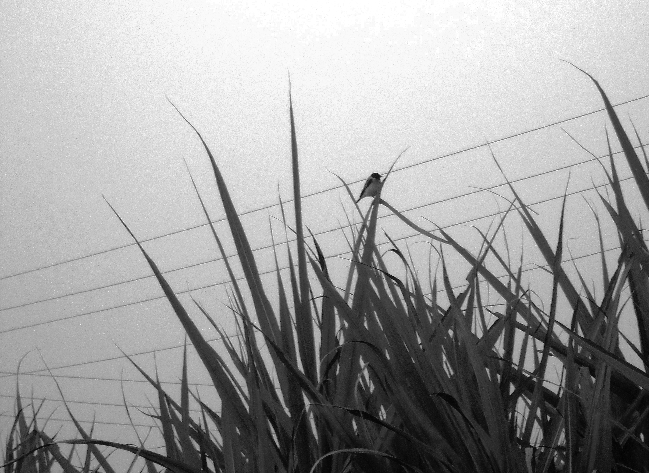
- What are the final words the fictitious author uses to end Part One of the novel? And what can the reader infer about why the author feels it is necessary to share this information?

- Mamaji assembles and mails photographs to Pi. In each box below write the descriptions and important information about each photograph:

PHOTOGRAPH 1 | PHOTOGRAPH 2
PHOTOGRAPH 3 | PHOTOGRAPH 4
ANALYSIS/SYNTHESIS
A motif is any recurring element in a story that has symbolic significance
Motif
- Find one passage (1-3 sentences) that reflects each motif below and write the passage word-for-word. Include the page number after your passage.
Projecting human qualities on animals:

Suffering:

Madness:

The word character derives from the Greek verb charassein, meaning to mark with a cut. Characterization is the method used by an author to develop a character. When an author introduces the reader to the characters within the work, he or she has two choices: to use direct and indirect characterization.

Characterization and Symbolism

- On page 86 the fictitious author makes this comment about Pi, “A smile every time, but his eyes tell another story.” What observation is he making about Pi?

Symbolism (Greek, `to throw together') - symbols-like metaphors, similes, personification, and allusions-are a type of figurative language. Symbols must be something material or visible such as colors, objects, animals, people, and places, while the idea it symbolizes must be something abstract or universal.

UNIVERSAL THEME

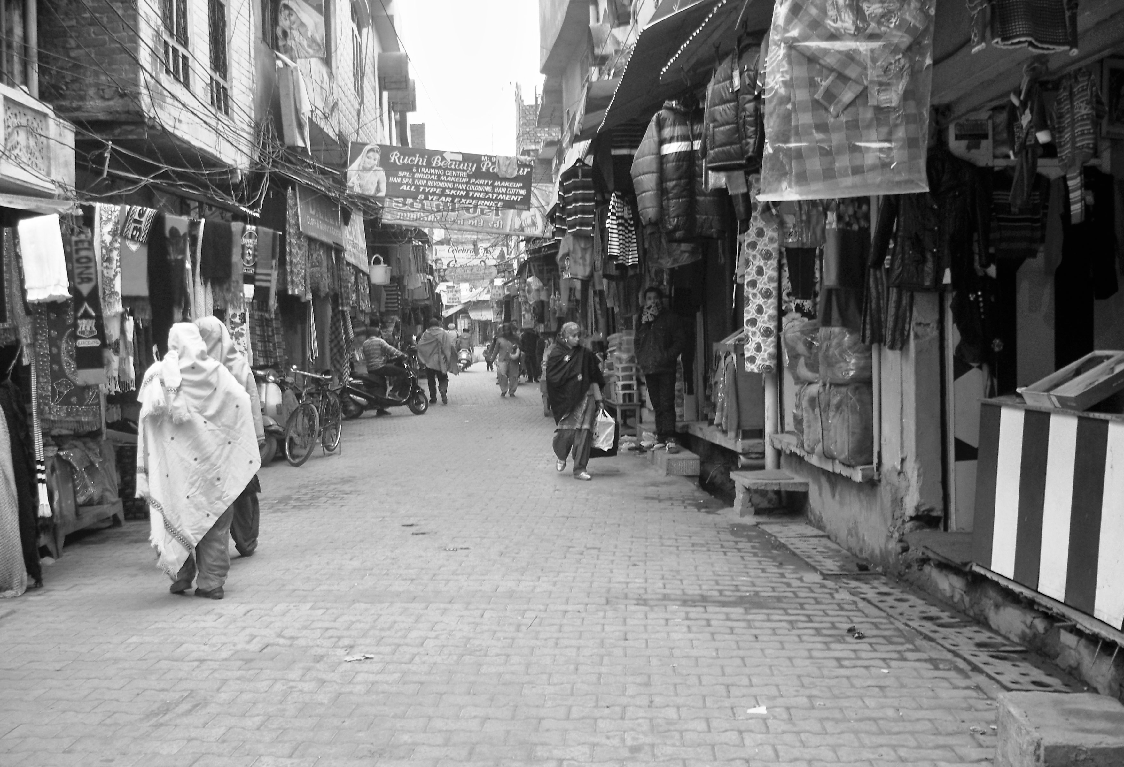
- The two Kumars meet when they both visit Pi at the zoo. Discuss briefly their attitudes about religion and science and then compare their reactions to the zebra. How do their reactions connect to an overall theme in the novel?

READER-RESPONSE/PERSONAL CONNECTION
Directions: Read the response question below and write one paragraph in the space provided.

- The fictitious author has noticed that Pi has a “smile every time, but his eyes tell a different story.” What does he mean by this comment? Can you learn about a person’s true feelings by looking into his or her eyes?

____________________________________________________________________________________________________________________________________________________________________________________________________________________________________________________________________________________________________________________________________________________________________________________________________________________________________________________________________________________________________________________________________________________________________________________________________________________________________________________________________________________________________________________________________________________________________________________________________________________________________________________________________________________________________________________________________________________________________________________________________________________________

ACROSS THE CURRICULUM/SUBJECT CONNECTION (Suggestion for further study)
Geography and Culture: Locate and research the swimming pool of the Aubrobindo Ashram
Biology: Research the Lincoln Park Zoo in Chicago, anthropomorphism and zoomorphism
Geography: Locate the Petit Seminaire school, Madras and find factual details about the school

