Name ____________________________

Date ________Class _______

Score _____________________
Life of Pi

Chapters 24-29
Activity Guide Questions

Directions: Read the chapters and answer the questions below in complete sentences.
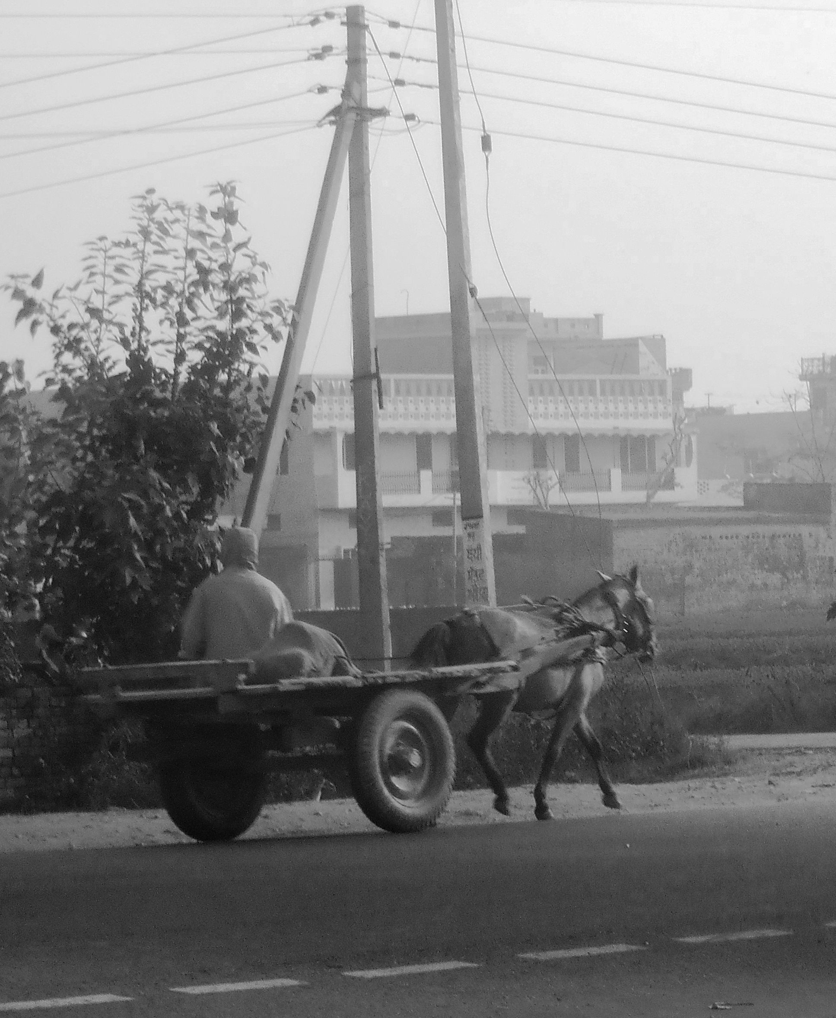
COMPREHENSION
- In Chapter 26 Pi asks his father for two things, what are they?

- According to Pi, why do people move?

- Why does Pi’s father move to Canada?

- Pi’s father demonstrates his support for technology when he compares one’s adaptation to technology with which biological theory?

- Fill-in-the-Blank: Pi’s mother is answering his question about how many nations are in the sky, “One. That’s the point. ____________________________, one passport.”
APPLICATION
- In chapter 25 on page 71, Pi says, “To me, religion is about our dignity, not our depravity.” Write the definition of dignity and depravity and paraphrase what Pi means by this statement.

Dignity:

Depravity:

Paraphrase:
The word character derives from the Greek verb charassein, meaning to mark with a cut. Characterization is the method used by an author to develop a character. When an author introduces the reader to the characters within the work, he or she has two choices: to use direct and indirect characterization.

ANALYSIS/SYNTHESIS

Diction and Characterization

- In Chapter 26, the reader learns more about Pi’s parents. Complete the chart using as many words and phrases from the chapter that support each character.

Father | Mother

Based on the supports, how would you describe Pi’s parents?

Father:

Mother:

Syntax and Parallel Structure
Syntax originates from the Greek words uυν meaning "together" and taxis meaning "sequence, order, arrangement." Syntax refers to grammatical order of words and sentence structure. The arrangement of words and phrases may be shifted to create emphasis, make a connection between two words, or suggest emotional implications.

- Underline key words and phrases in this passage:

People move because of the wear and tear of anxiety. Because of the gnawing feeling that no matter how hard they work their efforts will yield nothing, that what they build up in one year will be torn down in one day by others. Because of the impression that the future is blocked up, that they might do all right but not their children. Because of the feeling that nothing will change, that happiness and prosperity are possible only somewhere else. (page 79)
How does the use of parallel structure in this passage reveal the emotions of someone who feels it is necessary to move “somewhere else” in order to have a better life for their children?

A simile is defined as a comparison using the words like or as that show how two unlike things are similar in one important way.

Literary Devices and Simile

- Underline the word or phrase that is being described in the simile. Draw parentheses around the word or phrase it is being compared to.

Example: Her sadness was as unending as the (waves).

The water trickled down my face and down my neck; though just a beaker’s worth, it had the refreshing effect of a monsoon rain.

READER-RESPONSE/PERSONAL CONNECTION
Directions: Read the response question below and write one paragraph in the space provided.

- At the end of Chapter 25 Pi gives examples of how people “come between God and [him].” What does he mean by this statement? Is there a time in your life that you felt people kept you from exploring your own ideas about the world around you?

_________________________________________________________________________________________________________________________________________________________________________________________________________________________________________________________________________________________________________________________________________________________________________________________________________________________________________________________________________________________________________________________________________________________________________________________________________________________________________________________________________________________________________________________________________________________________________________________________________________________________________________________________________________________________________________________________________________________________________________________________________________________________________

ACROSS THE CURRICULUM/SUBJECT CONNECTION (Suggestion for further study)
History: Research Mrs. Gandhi, the Tamil Nadu government, and India’s constitution
Literature: Read about the authors Robert Louis Stevenson, Conan Doyle, R.K. Narayan and their works

