Name ____________________________

Date ________Class _______

Score _____________________
Life of Pi

Chapters 11-16
Activity Guide Questions

Directions: Read the chapters and answer the questions below in complete sentences.
COMPREHENSION
- Which animals are the best performers in a circus? Explain.
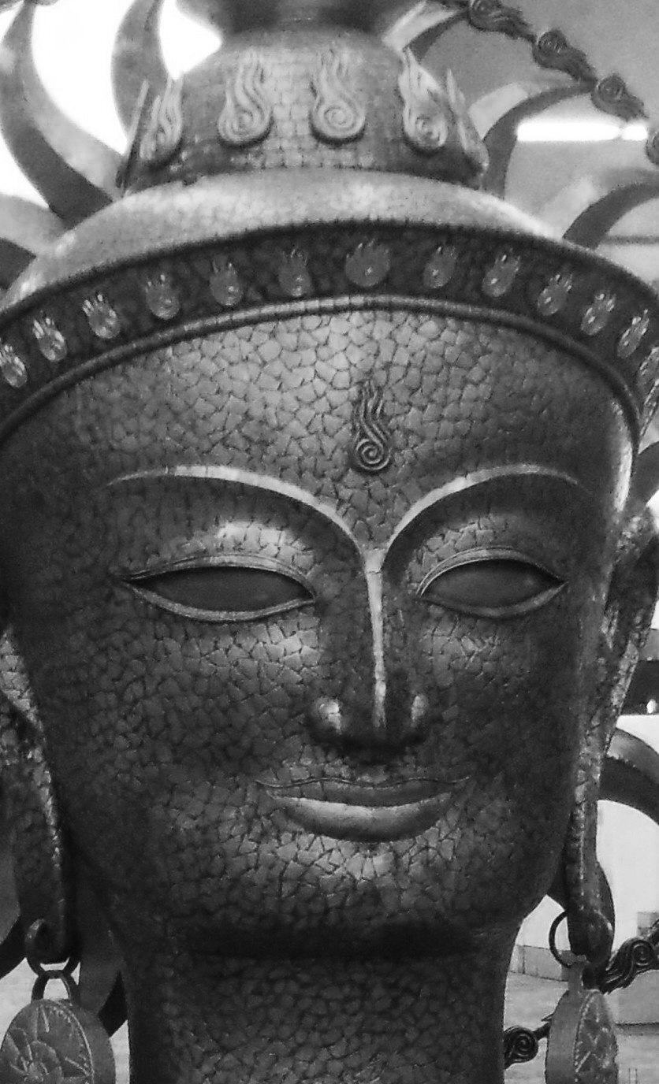

- Fill-in-the-Blank: The fictitious author makes this statement about Pi, “After all these years, _______________________ still preys on his mind.”

- Which religion is introduced to Pi by his parents?

APPLICATION
- What point is Pi making when he tells the story about the “female black leopard that escaped from the Zurich zoo in the winter of 1933”?

- In Chapter 13 Pi gives a detailed explanation of the techniques a circus trainer must use in order to train a lion. After the first paragraph, Pi dedicates each paragraph to the three specifics that a trainer must do in order to survive. List the three main points that Pi makes:

- In Chapter 15 the reader is introduced to Pi’s home in Canada. The fictitious author notices objects form three distinct religions in Pi’s home: Christianity, Islam and Hinduism. Read the chapter carefully and list the objects on the chart according to each religion.

Christianity | Islam | Hinduism

ANALYSIS/SYNTHESIS
A motif is any recurring element in a story that has symbolic significance
Motif
- Find one passage (1-3 sentences) that reflects each motif below and write the passage word-for-word. Include the page number after your passage.
Faith/reason:

Projecting human qualities on animals:

Mystical experience:

Personification is a type of figurative language. The use of personification is when an inanimate object is given the characteristics as being a living person or animal.
Figurative Language and Psychology
- On pages 42 the fictitious author’s statement, “Memory is an ocean and he bobs on its surface” is a reference to Pi’s story, his 227 day ordeal as a castaway on the Pacific Ocean.

Which two unlike things are being compared? ______________________ and ___________________

What is this metaphor suggesting about the memory of Pi’s experience?

Juxtaposition and Point of View
Juxtaposition is the act of placing close together or side by side, in order to compare or contrast specific objects, images, plot details, characters, themes et certera.

- Chapters 15 and 16 are juxtaposed in order to present Pi’s religious beliefs from an objective and subjective point of view. In Chapter 15 the fictitious author presents us with an objective description of the religious objects in Pi’s home. In Chapter 16 Pi reveals his personal, subjective religious beliefs. How does this juxtaposition of these two chapters relate to the concept of the mathematical symbol Pi?
Objective means something that is presented on facts, unbiased.

Subjective means something that is presented from one’s own personal thoughts and experiences.

UNIVERSAL THEME

- What is Pi suggesting when he says, “Hindus, in their capacity for love, are indeed, hairless Christians, just as Muslims, in the way they see the God in everything, are bearded Hindus, and Christians, in their devotion to God are hat wearing Muslims”?

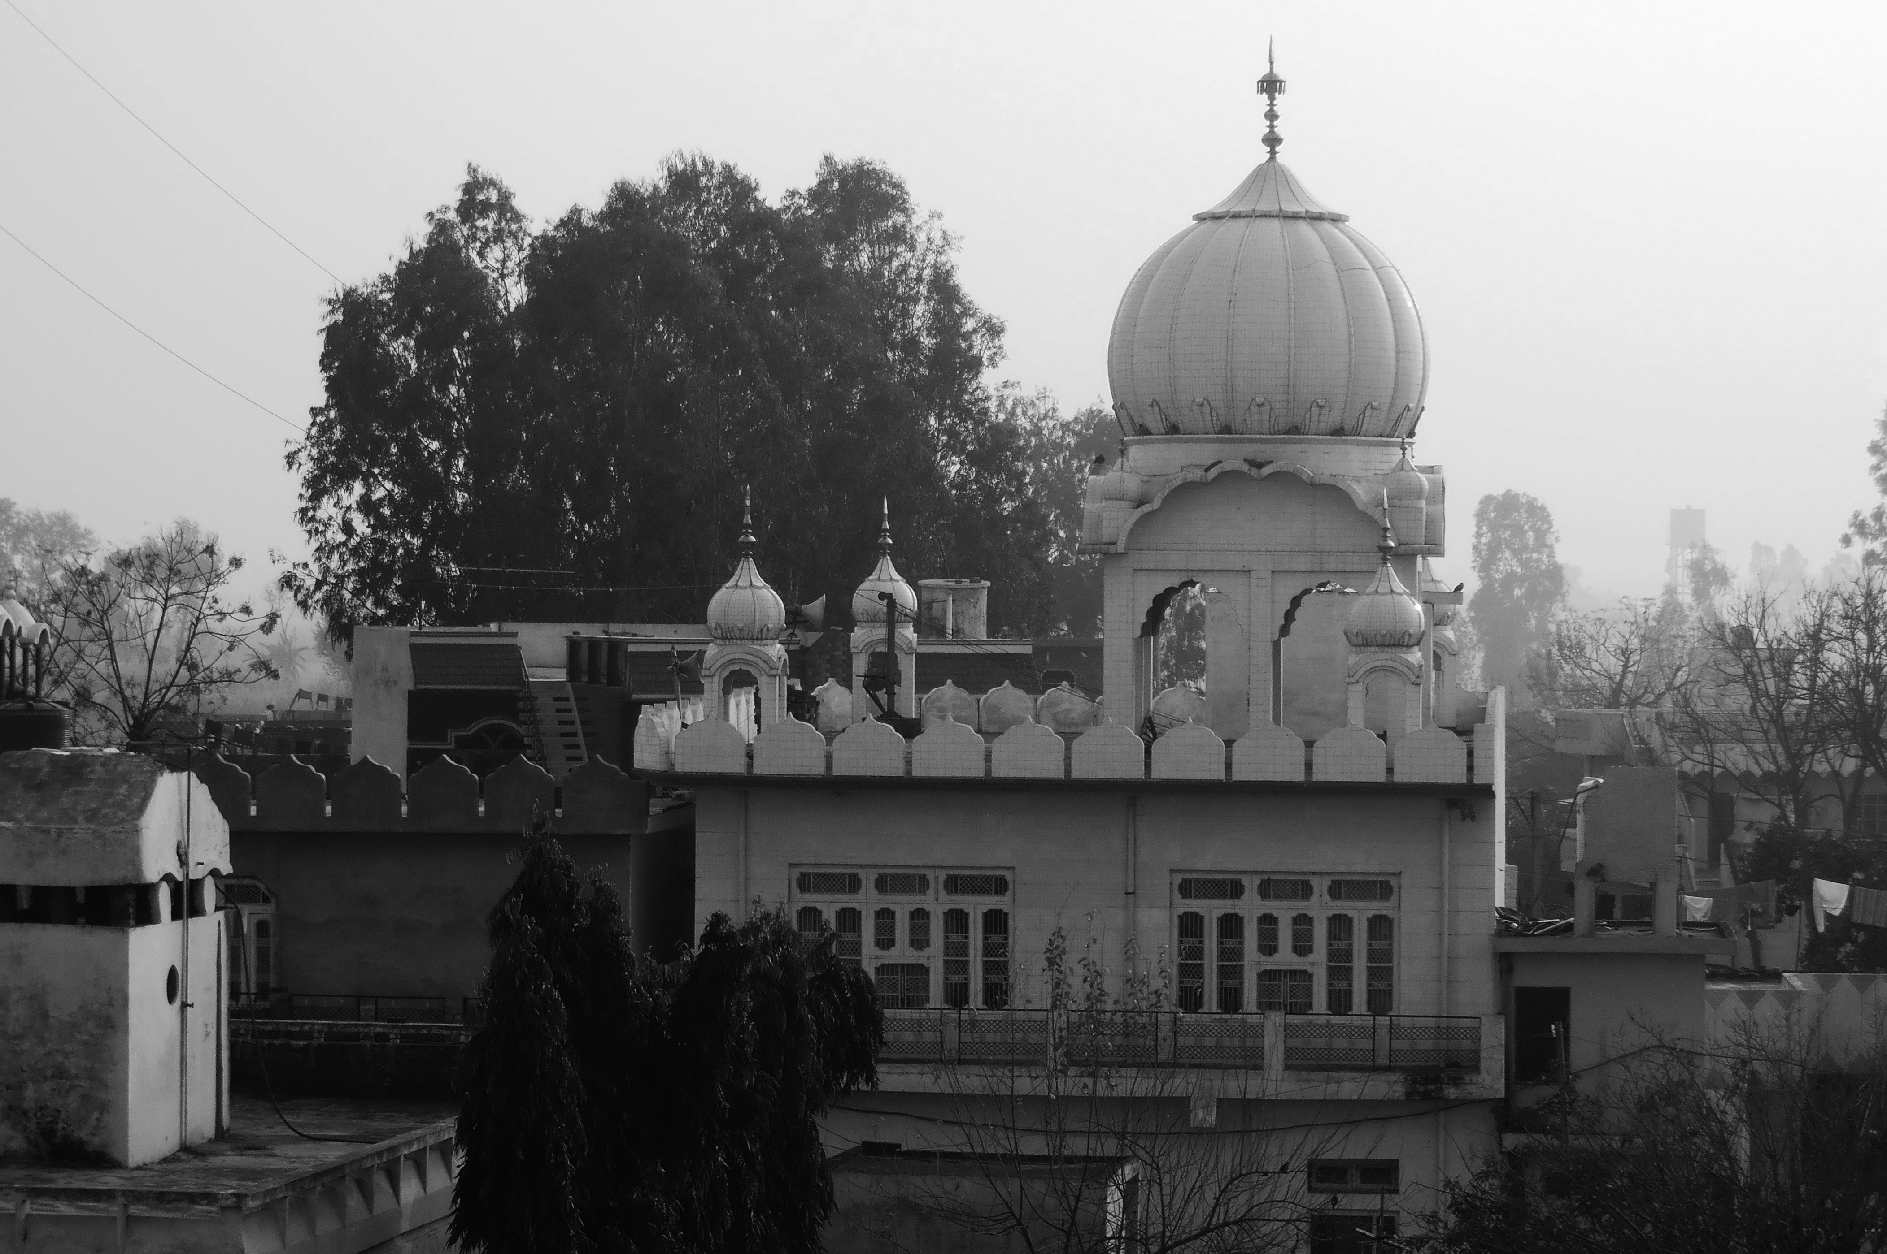
- Pi frequently references several key religious terms in his explanation about life: “The truth of life is that Brahman is no different from atman, the spiritual force within us, what you might call the soul. The individual soul touches upon the world soul like a well reaches for the water table. That which sustains the universe beyond though and language, and that which is at the core of us and struggles for expression, is the same thing. The finite within the infinite, the infinite within the finite.” What point is Pi making about the limitations of language in religions while trying to understand spirituality?

READER-RESPONSE/PERSONAL CONNECTION
Directions: Read the response question below and write one paragraph in the space provided.

- In chapter 13 Pi notes, “Much hostile and aggressive behavior among animals is the expression of social insecurity” (page 43). Does this idea hold true for humans? Explain.

________________________________________________________________________________________________________________________________________________________________________________________________________________________________________________________________________________________________________________________________________________________________________________________________________________________________________________________________________________________________________________________________________________________________________________________________________________________________________________________________________________________________________________________________________________________________________________________________________________________________________________________________________________________________________________________________________________________________________________________________________________________________________

ACROSS THE CURRICULUM/SUBJECT CONNECTION (Suggestion for further study)

History and Religion: Research the main tenants of Islam, Christianity, and Hinduism

