Name ____________________________

Date ________Class _______

Score _____________________
Life of Pi

Author’s Note, Part One: Toronto and Pondicherry Chapters 1-5
Activity Guide Questions

Directions: Read the chapters and answer the questions below in complete sentences.
COMPREHENSION
- Write the first line in the Author’s Note word-for-word?

- Fill-in-the-Blank: On page VIII of the Author’s note, the author says, “That’s what _______________ is about, isn’t it, the ________________________ transforming of __________________________.”

- What is the name of the old man who tells the author about Pi?

- On page 4 Pi discusses how the three–toed sloth survives. List a minimum of three key phrases.

- Anthropomorphism is defined as the “attribution of human characteristics to nonhumans.” Read pages 4-5 and list a minimum of three key phrases that include examples of anthropomorphism.

- In Chapter 1 who is the narrator and what is the point of view of this novel?

- Chapter 2 includes the author’s description of Pi. List a minimum of six phrases.

- Describe how Pi is named after a French swimming pool.

- Discuss why and describe how Piscine Molitor Patel takes on his new name, Pi.

APPLICATION
- What does the fictitious author mean when he writes, “…a novel set in Portugal in 1939 may have little to do with Portugal in 1939”?

- One of the most significant passages in the novel is the last sentence of the author’s note. Write the sentence word-for-word and then paraphrase what it means.
Passage:

Paraphrase:

- We learn that Pi attended the University of Toronto and took a double-major Bachelor’s degree in religious studies and zoology.
What was his thesis for his religious studies degree?

What was his thesis for his zoology degree?

What does this double-major reveal about Pi’s personality?

- Based on this passage on page 16, discuss Pi’s philosophy about fear: "Animals in the wild lead lives of compulsion and necessity within an unforgiving social hierarchy in an environment where the supply of fear is high and the supply of food low and where territory must constantly be defended and parasites forever endured.”

- Based on this passage on page 16, discuss Pi’s philosophy about freedom: “What is the meaning of freedom in such a context? Animals in the wild are, in practice, free neither in space nor in time, nor in their personal relations."

ANALYSIS/SYNTHESIS
Character Development
- Review the two passages below about Pi.
- Pi says, “repetition is important in the training not only of animals but also of humans”

- Pi says, “I went there three times a week throughout my childhood, a Monday, Wednesday, Friday early morning ritual with clockwork regularity of a good front-crawl stroke.”

Which words and phrases do the passages have in common? What do the words and phrases suggest about the habits of humans and animals?

Figurative Language and Allusion

One of the most important figurative language devices in the novel is the Memento Mori paintings allusion on page 5.

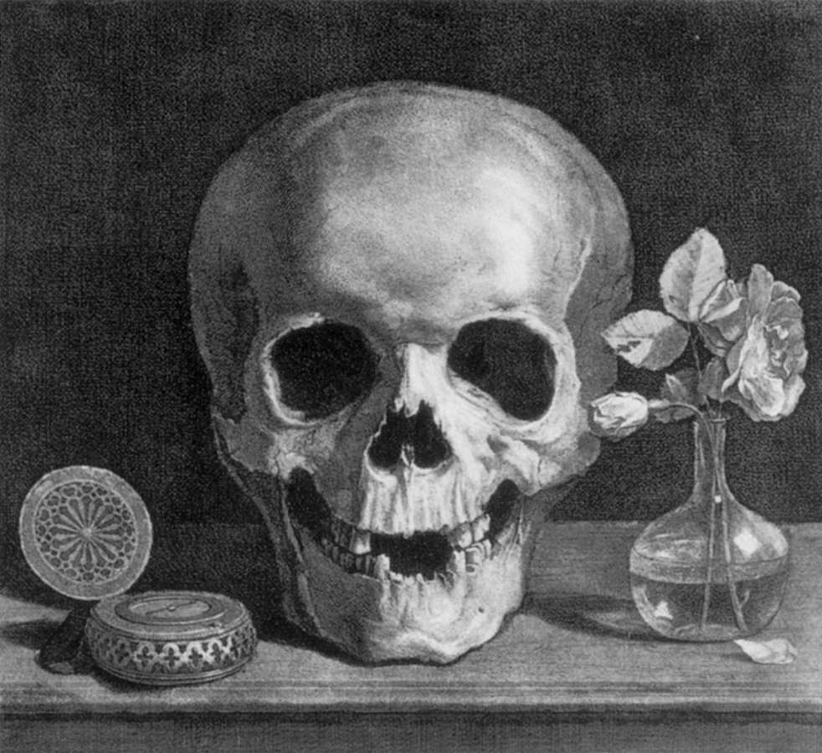
My life is like a memento mori painting from European art: there is always a grinning skull at my side to remind me of the folly of human ambition. I mock this skull. I look at it and I say, 'You've got the wrong fellow. You may not believe in life, but I don't believe in death. Move on!' The skull snickers and moves ever closer, but that doesn't surprise me. The reason death sticks so closely to life isn't biological necessity--it's envy. Life is so beautiful that death has fallen in love with it, a jealous, possessive love that grabs at what it can. But life leaps over oblivion lightly, losing only a thing or two of no importance, and gloom is but the passing shadow of a cloud.
Jean Morin - Memento Mori French graphic artist first half of 17th century

- How does the allusion to the Memento Mori reflect Pi’s state of mind? Use the image in the painting to help you construct your answer.

An allusion is a brief reference to a famous historical or literary figure or event that stimulates ideas, associations, and extra information in the reader's mind. An allusion may be drawn from history, geography, literature, or religion.
Memento Mori refers to art. It is a Latin phrase meaning "Remember you are mortal." Memento Mori art is designed to remind people of their mortality and the brevity and fragility of life. The art usually contains a skull and other symbols related to time, such as hour glasses and clocks, candles, fruit, and flowers.

Repetition and irony
Irony comes from the Greek eiron, which itself derives from eironeia, meaning "dissembling." In Greek drama, the eiron is a character who, although weaker than his opponent, the braggart alazon, defeats him by misrepresenting himself
- situational irony is when the situation is significantly different from what is expected
- dramatic irony is when the audience knows more than the characters in the play
- verbal irony is when the speaker intends to be understood as meaning something that contrasts with the literal meaning of what he or she says

- Read this passage and underline the key words and phrases that are repeated (other than the word I).

Richard Parker has stayed with me. I've never forgotten him. Dare I say I miss him? I do. I miss him. I still see him in my dreams. They are nightmares mostly, but nightmares tinged with love. Such is the strangeness of the human heart. (page 6)

What is ironic about the key words and phrases?

A paradox is defined as “a situation or a statement that seems to contradict itself, but actually takes these conflicting points to expresses a possible truth.” For example, this statement contains a paradox: “If you love someone, you would let her go.” Usually we identify loving someone with keeping that person close to us; however, the statement suggests that if you really love someone, you would be willing to sacrifice your own feelings, regardless how painful it might be, and let that person go, so she can be happy.

Paradox

- In Chapter 1 on page 5, Pi explains the effects of suffering, “When you’ve suffered a great deal in life, each additional pain is both unbearable and trifling.” Discuss the paradoxical nature of his explanation.

Figurative Language and Simile
A simile is defined as a comparison using the words like or as that show how two unlike things are similar in one important way.
- Underline the word or phrase that is being described in the simile. Draw parentheses around the word or phrase it is being compared to.

Example: Her sadness was as unending as the (waves).

“That pain is like an axe that chops at my heart.”

UNIVERSAL THEME
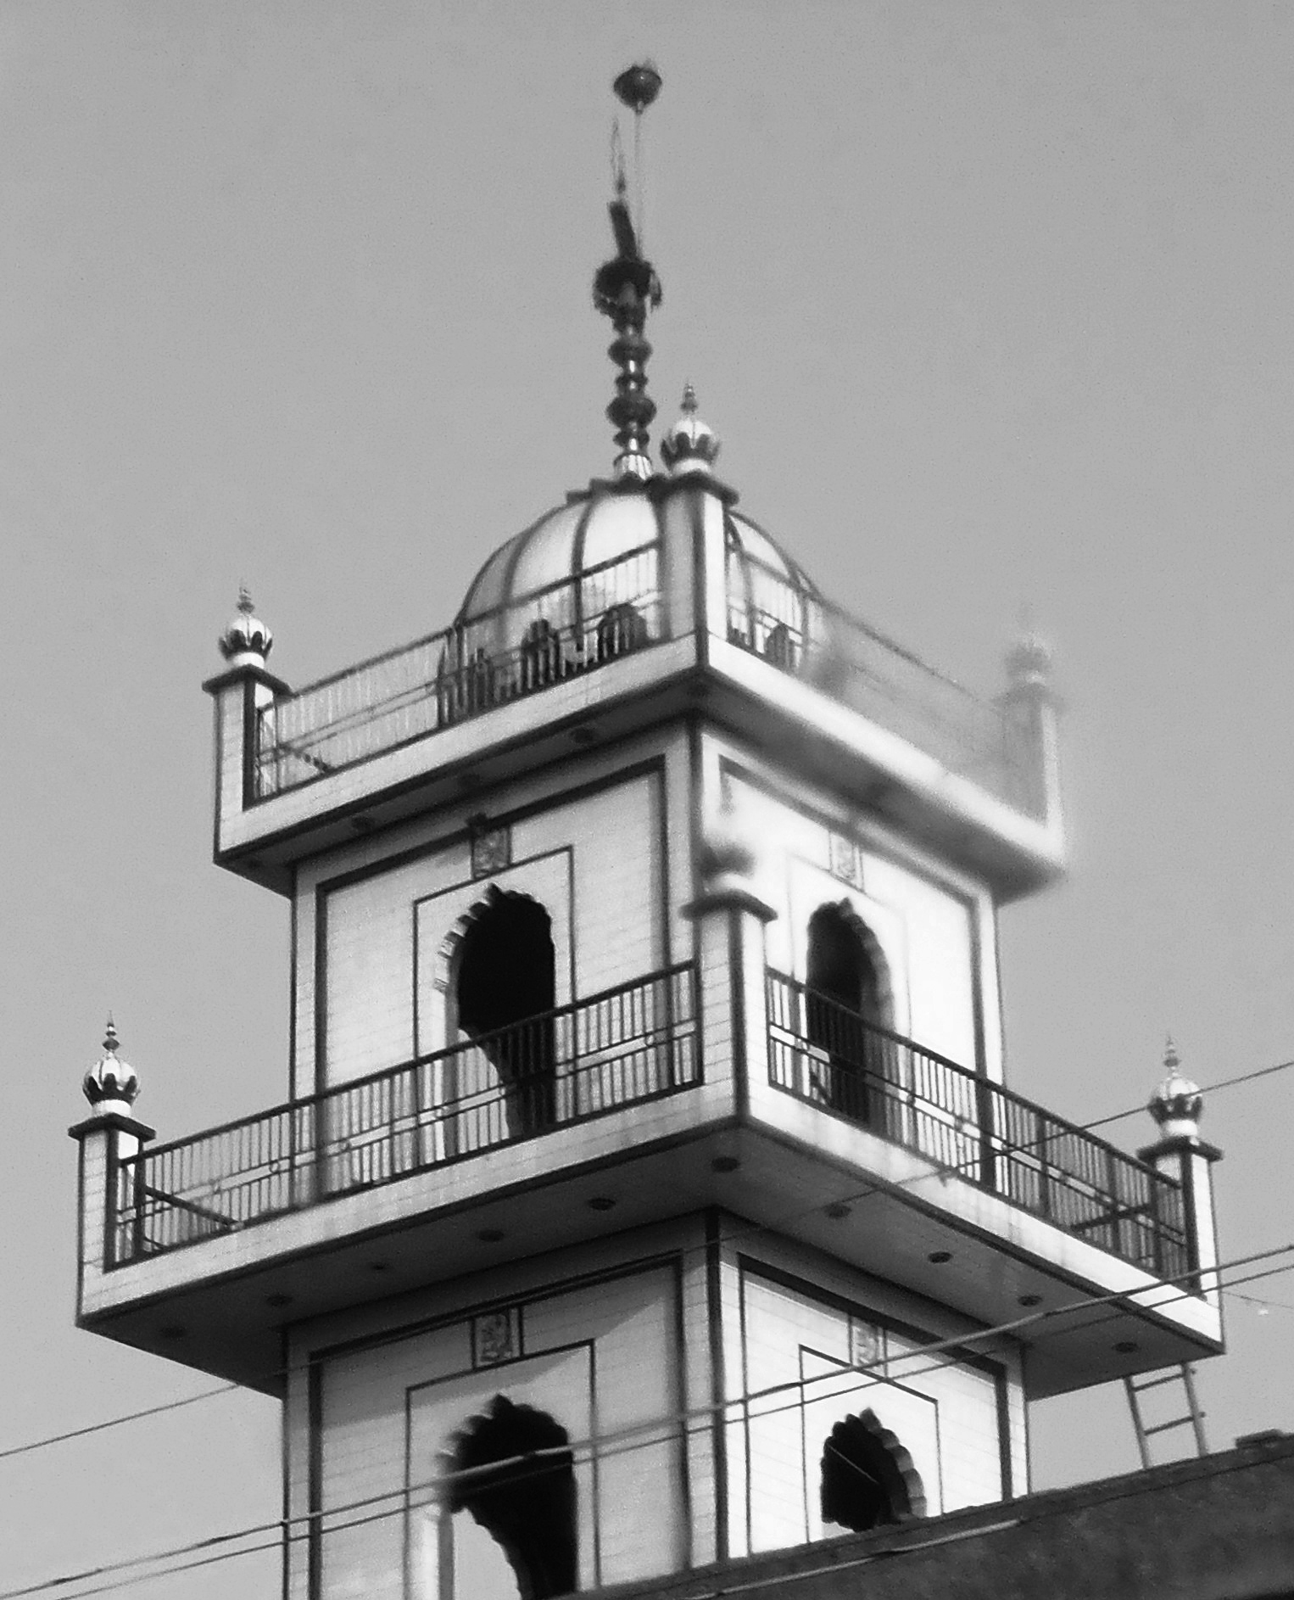
- Although Pi is articulate when discussing his past, he still finds it difficult to express his experiences through language, “I wish I could convey the perfection of a seal slipping into water or a spider monkey swinging from point to point or a lion merely turning its head. But language founders in such seas. Better to picture it in your head if you want to feel it.” Explain Pi’s point of view of the limitations of language.

READER-RESPONSE/PERSONAL CONNECTION

Directions: Read the response question below and write one paragraph in the space provided.

- Pi asks in Chapter 4, “Would you rather be put up in the Ritz with free room service and unlimited access to a doctor or be homeless without a soul to care for you?” What would your response be to Pi’s question?

_______________________________________________________________________________________________________________________________________________________________________________________________________________________________________________________________________________________________________________________________________________________________________________________________________________________________________________________________________________________________________________________________________________________________________________________________________________________________________________________________________________________________________________________________________________________________________________________________________________________________________________________________________________________________________________________________________________________________________________________________________________

