Name: _______________________________________ Date: __________________ Period: ______

Character and Theme Tracker: The Absolutely True Diary of a Part-Time Indian
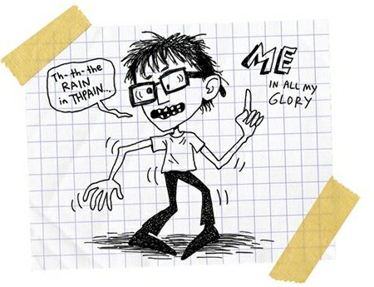

DIRECTIONS: As we read, fill out the STEAL graphic organizer for major characters in the text.

Arnold Spirit  AKA-Junior | ADJECTIVE | TEXTUAL EVIDENCE | EXPLANATION: What does this evidence convey?
Speech
Thoughts
Effects on Others
Actions
Looks

Rowdy | ADJECTIVE | TEXTUAL EVIDENCE | EXPLANATION: What does this evidence convey?
Speech
Thoughts
Effects on Others
Actions
Looks

Junior’s  Mom | ADJECTIVE | TEXTUAL EVIDENCE | EXPLANATION: What does this evidence convey?
Speech
Thoughts
Effects on Others
Actions
Looks

Junior’s  Dad | ADJECTIVE | TEXTUAL EVIDENCE | EXPLANATION: What does this evidence convey?
Speech
Thoughts
Effects on Others
Actions
Looks
Mr. P | ADJECTIVE | TEXTUAL EVIDENCE | EXPLANATION: What does this evidence convey?
Speech
Thoughts
Effects on Others
Actions
Looks

Theme Tracker

PART I DIRECTIONS: For each thematic topic listed below, note where it appears in the text by providing a quote from the text that demonstrates the topic.

THEMATIC TOPICS THAT APPEAR IN THE ABSOLUTELY TRUE DIARY OF PART-TIME INDIAN | EVIDENCE OF WHERE THIS TOPIC APPEARS [You should have AT LEAST 3 examples for EACH thematic topic below.]
Identity & Belonging

Hopes & Dreams

Poverty
Racism

PART II DIRECTIONS: Write a theme statement related to ONE of the thematic ideas listed above. Then, using the chart below, use Alexie’s characterization throughout the text to develop the theme. Provide an element of STEAL from the beginning, middle, and end of the story that connects to and creates the theme.

THEME STATEMENT
 | ELEMENT OF STEAL WITH EVIDENCE | EXPLAIN CONNECTION TO THEME
BEGINNING OF TEXT
MIDDLE OF TEXT
END OF TEXT

SAY vs. DO T-Chart

Charting Verbs
Use these to explain what the author is DOING in the text. (i.e. In the text, the author ________…)
Conveys | Illustrates | Develops
Demonstrates | Reveals | Describes

Directions: In the chart below, explain how the author uses elements in the text to create meaning. On the left side, fill in pieces from the text of what the author is literally saying. Then, on the right, explain what the author is DOING with that piece of the text. WHY does the author include this? Connect to the theme.

What is the author saying in the text?  (What is this section about? What is the content? What did I learn from this paragraph? What information is being presented?) | What is the author doing in the text?  (Giving an example… Interpreting data… Sharing an anecdote… Summarizing information… Revealing a theme…)

